Robert Call

Linux Admin

12/6/21

Outline of each Server

**Installs Needed**:

Epel-release-8-11.e18.noarch

Appstream

Tmux-2.7.1.e18X86_64

Emacs-commonX86_64 12:0.60.6.1-21.e18

Fail2ban noarch 0.11.2-1.e18

Cowsay noaarch 3.04-16.e18

Rubygems-2.7.6.3

Lolcat

**Dependencies**:

**Centos 8**:

Emacs: 10/27/21

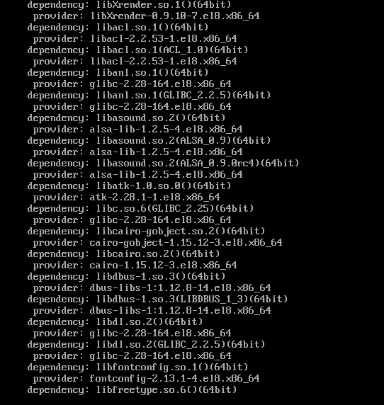

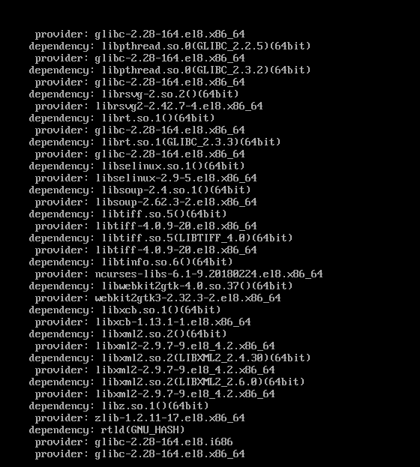

Timux: 10/25/21

Fail2ban: 10/28/21

Cowsay: 11/2/21

Lolcat: 11/3/21

We needed ruby for this which let us install lolcat from a gem

Vim: 11/2/21

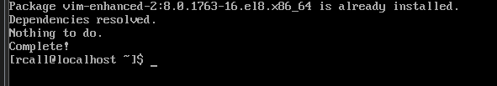

We did not need to install Vim we already had it in our base install packages



**Ubuntu Server**:

Emacs: 11/5/21

Tmux: 11/4/21

Fail2ban: 11/5/21

Cowsay: 11/6/21

Lolcat: 11/6/21

**Changes that needed to be made**:

**Centos 8:**

The biggest change was to install ruby to get lolcat and epel repository which contained most of are packages.

**Ubuntu Server:**

Mostly everything came with the packages we installed when we sett he server up. Other then pulling in dependencies are programs installed with no issues over all it seems ubuntu was the easier of the two to setup.